**Tech Saksham**

Case Study Report

**ANALYSIS OF COMMERICAL ELECTRICITY CONSUMPTION IN INDIAN STATES**

**APC Mahalaxmi College for Women**

|  |  |
| --- | --- |
| NM ID | NAME |
| 1DA07A4B482402983124C101C1AA3CBD | Sahaya Jeyashree.D |

Trainer Name: Arockiya Jeyanthi

Master Trainer: Uma

**ABSTRACT**

In the digital age, data has become an invaluable asset for businesses, particularly in the banking sector. The proposed project, “Real-Time Analysis of Bank Customers”, aims to leverage PowerBI, a leading business intelligence tool, to analyse and visualize real-time customer data. This project will enable banks to gain deep insights into customer behaviour, preferences, and trends, thereby facilitating data-driven decision-making and enhancing customer satisfaction. The real-time analysis will allow banks to respond promptly to changes in customer behaviour or preferences, identify opportunities for cross-selling and up-selling, and tailor their products and services to meet customer needs. The project will also contribute to the broader goal of digital transformation in the banking sector, promoting efficiency, innovation, and customer-centricity.

**INDEX**

|  |  |  |
| --- | --- | --- |
| **SR .No.** | **Table of contents** | **Page.No.** |
| 1 | Chapter 1: Introduction | 4 |
| 2 | Chapter 2:Serives and Tool required | 7 |
| 3 | Chapter 3:Project Architecture | 9 |
| 4 | Chapter 4:Modeling and Result | 11 |
| 5 | Dashboard | 13 |
| 6 | Conclusion | 16 |
| 7 | References | 17 |
| 8 | Links | 17 |

**CHAPTER 1**

**INTRODUCTION**

**1.1 Problem Statement**

Commercial electricity consumption in Indian states is a critical aspect of understanding the economic activity and energy demand dynamics within the country. The analysis of commercial electricity consumption seeks to uncover trends, patterns, and factors influencing electricity usage in this sector across different states in India. Examine the historical trend of commercial electricity consumption in Indian states over a specified period. Identify regional disparities in commercial electricity consumption and explore the reasons behind them. Break down commercial electricity consumption into sub-sectors such as retail, hospitality, offices, etc., to understand consumption patterns. Analyse the impact of government policies, incentives, and regulations on commercial electricity consumption. Assess the level of energy efficiency in commercial establishments and identify opportunities for improvement.

**1.2. Proposed Solution**

Understanding the intricacies of commercial electricity consumption in Indian states is imperative for effective energy management, economic planning, and sustainable development. This analysis aims to delve into the patterns, trends, and factors influencing commercial electricity usage across various states in India, providing insights for policymakers, energy regulators, businesses, and other stakeholders. Investigate historical trends in commercial electricity consumption across Indian states over a specified period to identify growth patterns and variations. Analyse electricity consumption patterns within different commercial sectors (e.g., retail, hospitality, offices) to understand sector-specific demands.

**1.3. Feature**

To conduct a comprehensive analysis of commercial electricity consumption in Indian states, several features need to be considered. These features will help in understanding the dynamics of electricity usage, identifying trends, and uncovering factors influencing consumption patterns. Here are some essential features to include in the analysis. Categorize commercial establishments into sub-sectors such as retail, hospitality, offices, healthcare, education, etc., as

1. **Total Consumption:** Begin by examining the total commercial electricity consumption in each Indian state over a specific period. This serves as a baseline for comparison and understanding the overall demand.

2. **Per Capita Consumption:** Calculate the commercial electricity consumption per capita in each state. This helps in assessing the efficiency of energy usage and comparing consumption levels across states with varying populations.

3. **Sector Wise Breakdown:** Analyse the distribution of commercial electricity consumption across different sectors such as manufacturing, services, hospitality, and others. Understanding the proportion of electricity consumed by each sector provides insights into the composition of economic activities driving energy demand.

**1.4. Advantages**

Analysing commercial electricity consumption in Indian states offers several advantages:

**Resource Allocation:** By understanding consumption patterns, policymakers can allocate resources effectively for infrastructure development, ensuring that electricity supply meets the demands of commercial establishments.

Energy Planning: Analysis helps in long-term energy planning by forecasting future electricity demand trends, enabling authorities to make informed decisions regarding capacity expansion, grid modernization, and energy diversification.

**Risk Mitigation:** Identifying regions with high dependency on commercial electricity consumption enables policymakers to mitigate risks associated with supply disruptions, price volatility, and energy security concerns.

Overall, analysing commercial electricity consumption in Indian states empowers stakeholders with valuable insights to optimize energy management, foster economic growth, mitigate environmental impacts, and enhance the overall efficiency and sustainability of the electricity sector.

**1.5. Scope**

The scope of analysing commercial electricity consumption in Indian states is broad and multifaceted, encompassing various dimensions of energy usage, economic activity, policy frameworks, and environmental considerations.

**Geographical Coverage:** The analysis covers all Indian states and union territories, considering the diverse regional characteristics, economic profiles, and energy infrastructure across the country.

**Temporal Coverage:** The analysis spans multiple years to capture trends, seasonal variations, and the impact of policy changes over time. Longitudinal data analysis enables a comprehensive understanding of commercial electricity consumption dynamics.

**Data Sources:** The analysis utilizes reliable and comprehensive data sources, including government reports, industry databases, energy surveys, and satellite imagery analysis. Access to granular data facilitates accurate assessments at the state and regional levels.

By addressing these aspects comprehensively, the analysis of commercial electricity consumption in Indian states provides valuable insights for policymakers, energy planners, investors, businesses, and other stakeholders to support informed decision-making, promote sustainable development, and achieve energy security goals.

**CHAPTER 2**

**SERVICES AND TOOLS REQUIRED**

**2.1 Services Used**

There are no specific services directly used for electricity consumption. Electricity is a final product delivered by utility companies. However, there are services that can help you monitor and manage your electricity consumption. These services can provide you with information about your hourly, daily, or monthly electricity use, and they can also help you identify ways to save energy.

Some popular energy monitoring services include:

**Sense**

[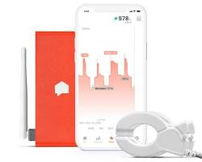](https://www.amazon.com/Sense-Energy-Monitor-Electricity-Usage/dp/B075K6PHJ9)

**Ohm Connect**

[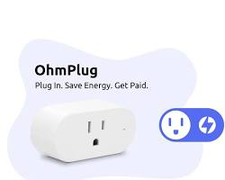](https://shop.ohmconnect.com/products/new-ohmplug-smart-plug-with-energy-monitoring)

These services typically require you to install a device in your home that tracks your electricity use. The device then transmits the data to the service provider, which makes it available to you online or through a mobile app.

2.2. Tools and Software Used

There are two main categories of tools and software used in electricity consumption: those for **Measurement** and those for **Management**.

**Measurement Tools:**

Energy Meters: These physical devices are installed in homes or buildings to measure the amount of electricity being used. They track total consumption over time and can be read manually or transmit data wirelessly.

Energy Sensors: These are smaller devices that can be installed on specific appliances or circuits to track the energy consumption of those individual components. This can help identify areas where you are using the most electricity.

**Management Software:**

Metering Software**:** This software collects and analyses data from energy meters and sensors. It can provide real-time or historical data on your electricity usage, identify patterns and trends, and generate reports

Energy Management Software**:** This is a more comprehensive software solution that integrates with metering software and other building systems (like lighting or HVAC) to help you optimize your energy use. It can provide recommendations for reducing consumption, automating control systems, and setting goals.

**CHAPTER 3**

**PROJECT ARCHITECTURE**

**Architecture:**

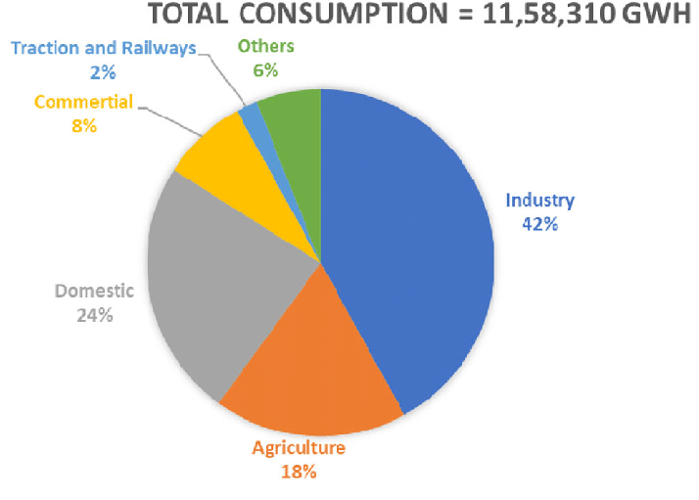

Architecture plays a significant role in influencing the electricity consumption of a building.

**Passive Design Strategies:**

These strategies rely on building elements and natural resources to achieve thermal comfort and lighting needs, reducing the reliance on mechanical heating, cooling, and artificial lighting systems.

Building Orientation and Shape: A well-oriented building can maximize solar heat gain in winters and natural ventilation in summers. Compact building shapes minimize exterior wall surface area, reducing heat transfer.

[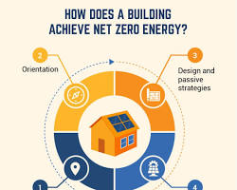](https://vitality.io/how-does-building-orientation-affect-energy-efficiency/)

Window Placement and Design: Strategically placed windows with appropriate overhangs allow natural light to penetrate deep into the building, reducing dependence on artificial lighting.

Building Materials: The selection of building materials can also impact electricity consumption. For example, materials with high thermal mass can help regulate indoor temperatures, reducing the need for heating and cooling systems.

**Active Design Strategies**

These strategies involve incorporating energy-efficient technologies and building systems to manage electricity consumption.

High Performance HVAC Systems: Energy-efficient heating, ventilation, and air conditioning (HVAC) systems use less electricity to maintain comfortable indoor temperatures.

[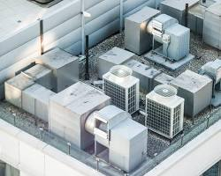](https://castlegreenfinance.com/high-performance-hvac-systems/)

**LED Lighting:** LED lighting is significantly more energy-efficient than traditional incandescent or fluorescent bulbs

**CHAPTER 4**

**MODELING AND RESULT**

**Popular Modelling Techniques:**

1. **Statistical Regression Models:**

* **Results:** Effective for short-term forecasting (hourly, daily) and identifying key factors influencing consumption (weather, economic activity).

**Example:** A regression model might show a strong correlation between temperature and electricity demand, helping predict peak usage during heatwaves.

1. Bottom-Up Engineering Models:
   * **Results:** Provide detailed consumption profiles for specific buildings or appliances. Useful for designing energy-efficient buildings and optimizing appliance usage.

**Example:** A bottom-up model could simulate the energy consumption of a house throughout a day, considering factors like insulation, HVAC system, and occupant behaviour.

1. Machine Learning (ML) Models:

* **Results:** Powerful for long-term forecasting, identifying complex relationships, and anomaly detection. Can handle large datasets and uncover hidden patterns.

**Example:** An ML model might analyze historical consumption data along with weather forecasts and social media trends to predict electricity demand during major holidays.

**Popular Results Techniques:**

* **Model Validation:** The accuracy of any model relies on its validation with real-world data. Comparing model predictions with actual consumption is crucial.
* **Data Quality:** The quality of input data significantly impacts results. High-resolution data from smart meters provides better insights than aggregated consumption figures.
* **Model Complexity vs. Interpretability:** Simpler models are easier to understand but may miss subtle relationships. Complex models can be more accurate but require expertise to interpret.

**Examples of Applications:**

* **Power Grid Management:** Models help utilities optimize electricity distribution, considering real-time consumption, renewable energy integration, and potential grid congestion
* **Demand-Side Management:** Utilities can identify high-consumption customer segments and target them with energy-saving programs or time-based pricing plans based on model insights.
* **Energy Efficiency Initiatives:** Policymakers can use models to evaluate the effectiveness of energy efficiency programs and forecast their impact on overall consumption.

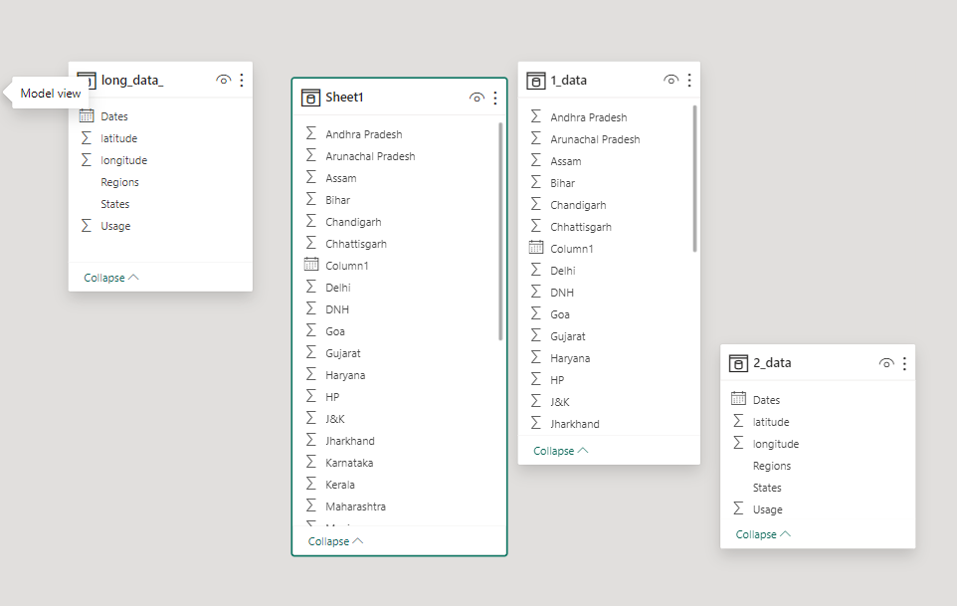

**Dashboard**

We are apply sum of longitude of region given in the dataset

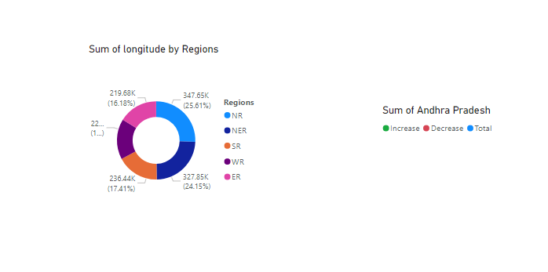

Sum of usage of the electricity by states in Indian

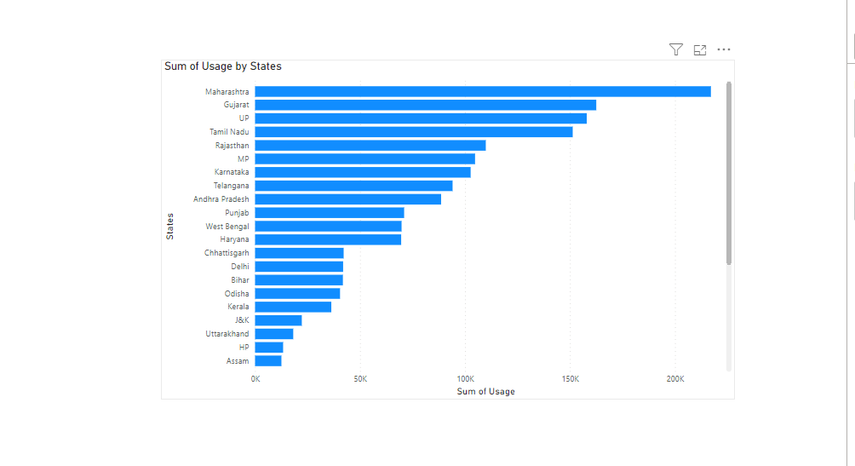

In the bar chart, x-axis is sum of usage and y-axis is states where located in India. Consumption of the electricity in state.

In SR region, TamilNadu states in 151,271,50 sum of usage

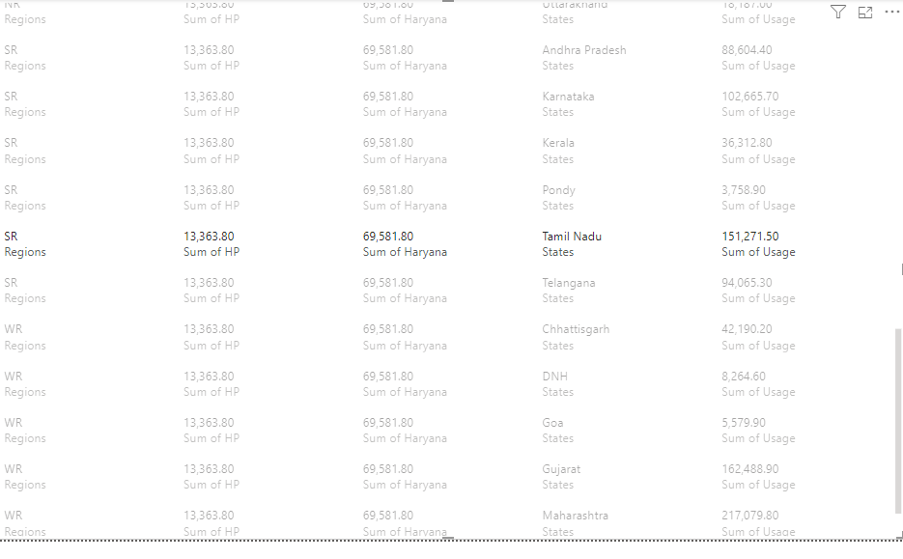

In this we use the application to create the dashboard in powerBI, using the dataset of electricity consumption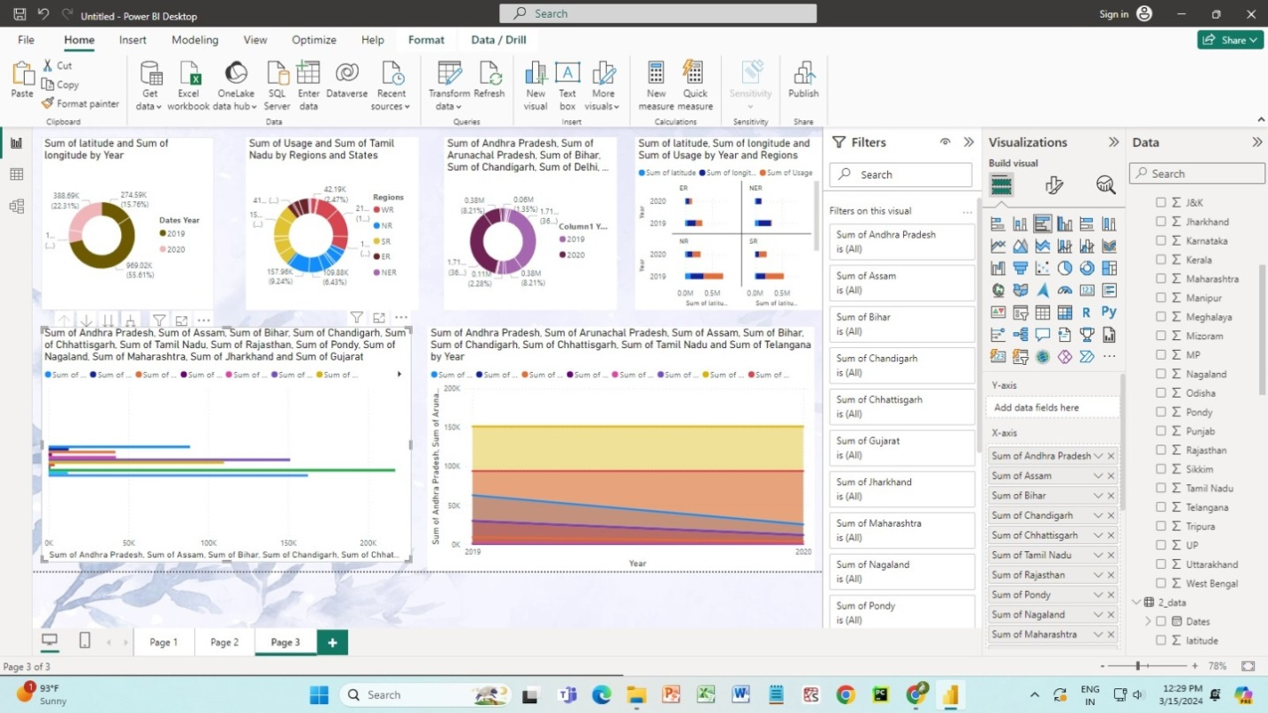

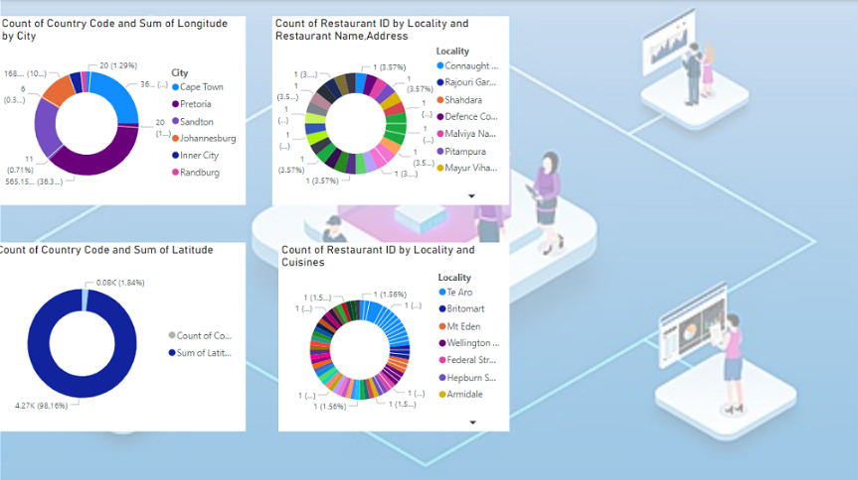

**Conclusion:**

By acknowledging the factors that influence electricity consumption and implementing a combination of design-oriented solutions and behavioural changes, we can create a more sustainable future with lower energy demands and a healthier planet.

**Future Scope:**

Analysing the feature scope of Tamil Nadu's electricity consumption involves examining various aspects related to the demand, supply, distribution, and management of electricity in the state. Here's a breakdown of potential areas to consider

**Historical Consumption Trends:** Analyse historical data to understand how electricity consumption in Tamil Nadu has evolved over the years. This includes examining patterns such as seasonal variations, annual growth rates, and shifts in consumption trends.

**Current Consumption Patterns:** Assess the current electricity consumption patterns in Tamil Nadu, including sector-wise consumption (residential, commercial, industrial, agricultural), urban-rural distribution, and peak demand periods.

**Factors Influencing Consumption:** Identify the factors influencing electricity consumption in the state. This could include population growth, economic development, industrialization, technological advancements, lifestyle changes, and government policies.

**Renewable Energy Integration:** Explore the integration of renewable energy sources such as solar, wind, and hydroelectric power into Tamil Nadu's electricity grid. Assess their contribution to overall electricity generation and consumption patterns.

**Energy Efficiency Measures:** Investigate efforts to promote energy efficiency and conservation in Tamil Nadu, such as energy-efficient appliances, building codes, and industrial processes. Evaluate their impact on reducing electricity consumption.

By exploring these aspects, stakeholders can gain a comprehensive understanding of Tamil Nadu's electricity consumption landscape and develop strategies to ensure sustainable, reliable, and affordable electricity supply for the state's residents and industries.

**Reference:**

[**https://en.wikipedia.org/wiki/Electric_energy_consumption**](https://en.wikipedia.org/wiki/Electric_energy_consumption)

[**https://en.wikipedia.org/wiki/Electricity_sector_in_India**](https://en.wikipedia.org/wiki/Electricity_sector_in_India)

[**https://www.sciencedirect.com/science/article/abs/in/India**](https://www.sciencedirect.com/science/article/abs/in/India)

**Links:**